Medical History
Patient’s name: _____________________________________ _ Date: _________________
Current Condition:
What is the problem you are here for? __________________________________________________________________
__________________________________________________________________________________________________
What is the date the problem started? ________________
Have you had similar symptoms in the past? ☐ Yes ☐ No If Yes, when? / /
What is your occupation? _________________________________
Current work status: ☐Full time ☐Part time ☐Self-employed ☐Retired ☐Off work ☐Other_______________
Have you seen anyone else for your current condition (check box/boxes)?
☐Physician/MD ☐Chiropractor ☐Podiatrist ☐Ortho surgeon ☐Massage
☐Dentist ☐Neurologist ☐Physical Therapist ☐Other ____________
Doctor/Therapist/Dentist/Practice Name:
Past medical History:
Have you ever had any of the following conditions? Check all that apply.

☐Alcohol use ____________ _
☐Alzheimer’s / Dementia
☐Asthma
☐Bowel/Bladder problems
☐Cancer History
☐Cardiovascular Disease
☐Cerebral Vascular Accident
☐Current Infection
☐Depression / Anxiety
☐Diabetes Type 1 or Type 2
☐Fainting/dizziness
☐Fall(s) History
☐Fibromyalgia
☐Fracture or Suspected Fracture
☐Headaches
☐Hearing problems
☐Heart condition
☐High blood pressure
☐Lung problems
☐Osteoarthritis
☐Osteopenia
☐Osteoporosis
☐Peripheral neuropathy
☐Rheumatoid arthritis
☐Seizures/epilepsy
☐Stroke
☐Thyroid problems
☐Tobacco use
☐Vision problems
☐Other___________________

Please list any current Medications (include over the counter meds) and Supplements, please include specific dosages of each medication / supplement. You may provide a list to attach.
Meds / Supplement | Dosage | Frequency | Route | Comments
 |  |  | ☐Oral ☐Inject ☐Dermal ☐Rectal
 |  |  | ☐Oral ☐Inject ☐Dermal ☐Rectal
 |  |  | ☐Oral ☐Inject ☐Dermal ☐Rectal
 |  |  | ☐Oral ☐Inject ☐Dermal ☐Rectal
 |  |  | ☐Oral ☐Inject ☐Dermal ☐Rectal
Please list all surgeries (include approximate date):
Type of Surgery | Appx Date | Comment
Please list all allergies

Patient name: ___________________________________ Date: ________________________

Please draw/mark where your pain is on the below body diagram (use symbols below to represent your pain).
Numbness - - - - - - Burning xxxxxx Aching ooooooo Stabbing /////////

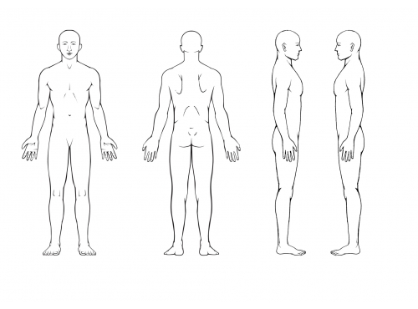

Rate your pain on the following scale (0 being no pain at all and 10 the worst imaginable pain ever):
Rate what it has been in the last 24 hours.
Worst: 0 1 2 3 4 5 6 7 8 9 10
Current: 0 1 2 3 4 5 6 7 8 9 10
Best: 0 1 2 3 4 5 6 7 8 9 10

